**HW 25**

hw-lect25-1

#a

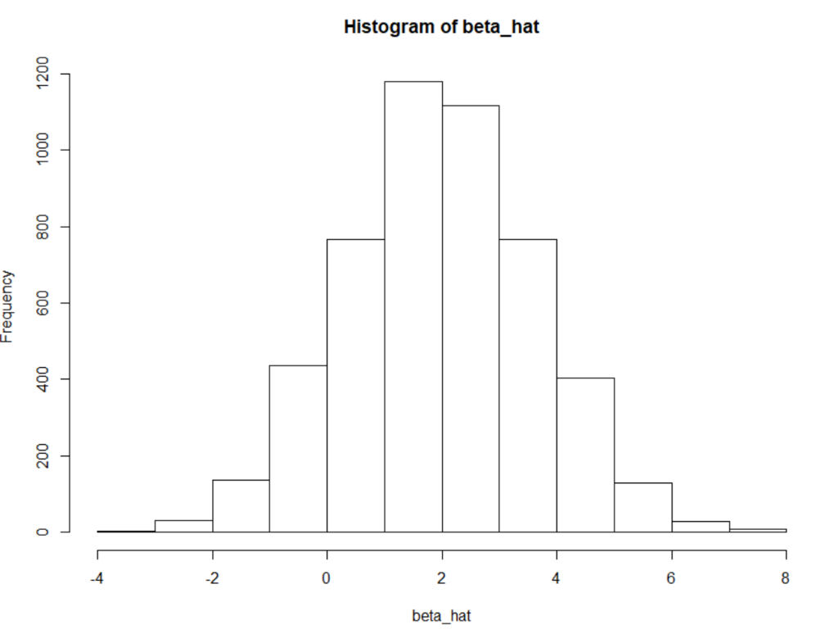

#b

The mean of the histogram is 1.969 which is very close to the true slope, which is 2.

#c

The standard deviation of the histogram is 1.643 and sigma_eps/sqrt(Sxx) equals 1.651. As such these values are approximately equal.

#d

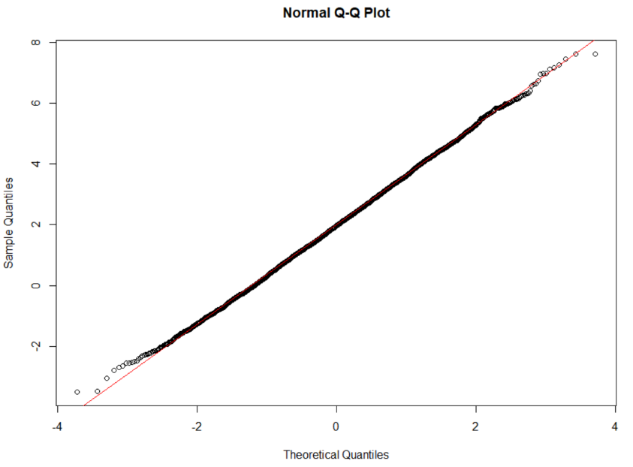The distribution is normal with N(2, 1.64) because these parameters fit the qqplot well.

Code used:

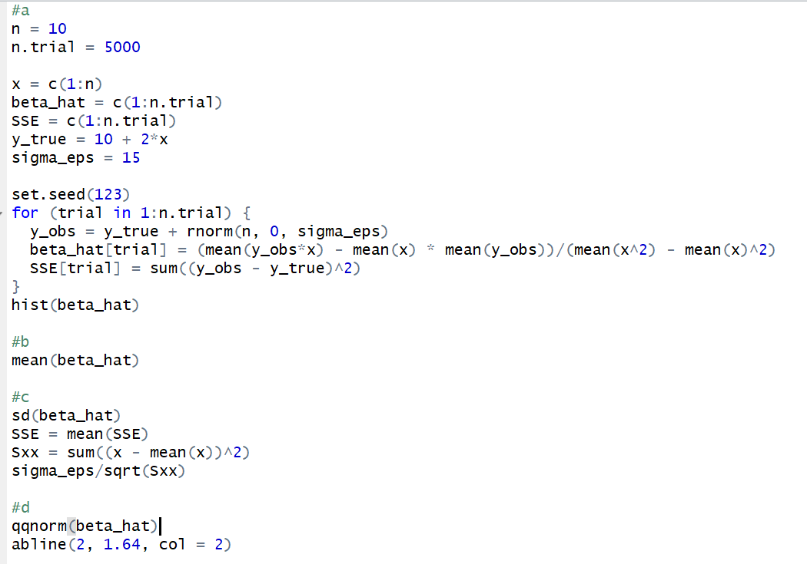

hw-lect26-2

#a

(Look at code below and next two parts)  
  
#b

The p-value is 0.2846 and alpha is 0.1. Since the p-value is greater than alpha we cannot reject the null hypothesis, providing evidence for the claim that the predictors might not be useful.

#c

At alpha = 0.1, only x1 and x6 have p-values less than alpha, at 0.076 and 0.017 respectively. As such we can reject the null hypothesis for x1 and x6, providing evidence for the claim that these predictors are useful.

Code below

